**Project Name:**

**Development of a Research & Development Website**

**Submission Date: 01/02/2025**

**Competition Name : JIS GEPO & RFMO Website Competition 2025**

**Team Name: Byte Coders**

**Members:**

**Sayan Bera**

**Bikram Koley**

**Parijat Dutta**

**Table of Content**

1. **Introduction ………………………………………………………………………….**
2. **Target Audience & Problem It Solves :………………………………………….**
3. **Technology Stack ………………………………………………………………….**
4. **Website Workflow Diagram (Flowchart/UI Navigation)……………………….**
5. **Working Flow with Screenshots …………………………………………………**
6. **Testing & Debugging………………………………………………………………**
7. **Future Improvements & Scalability………………………………………..**

**1. Introduction**

The Research & Development (R&D) website for the JIS Research Facilitation & Monitoring Office (RFMO) is designed to enhance the management and accessibility of research grant opportunities within the JIS Group. This platform serves as a central hub where faculty members can explore, apply for, and track research grants, while RFMO administrators can easily manage, evaluate, and monitor ongoing projects.

The website features key functionalities like grant listings, user registration, secure login, project proposal submissions, and real-time project tracking. It also includes an admin portal for overseeing all activities and generating reports. The website aims to streamline the R&D process, improve transparency, and foster collaboration across the institution.

This documentation provides an overview of the website's features, design, and technology stack, outlining the development process and how the platform meets the needs of both researchers and administrators.

The website includes:

* **Grant listings**
* **User registration & secure login**
* **Project proposal submission**
* **Real-time project tracking**
* **Admin portal for oversight & report generation**

The goal is to **streamline** the R&D process, improve **transparency**, and **foster collaboration** across the institution.

**2. Target Audience & Problem It Solves :**

Target Audience:

* Faculty members (Researchers & Professors)
* Principals of institutions
* Administrators (RFMO Officials)

Problems Solved:

* Simplifies grant applications & tracking
* Improves project transparency & accountability
* Provides a centralized management system for RFMO
* Enhances collaboration between faculties & institutions
* Ensures better monitoring & reporting of research projects

**3. Technology Stack :**

**Frontend**

* HTML, CSS → For structuring and styling the user interface.
* JavaScript → Handles interactivity and dynamic content.

**Backend**

PHP → used for backend scripting.

MySQL → Manages structured data, including users, grants, and proposals.

**4. Website Workflow Diagram (Flowchart/UI Navigation)**

Workflow of this R&D website can be divided into 3 sub parts.

1. Admin side
2. Principle side
3. Faculty side

**i.admin side :**

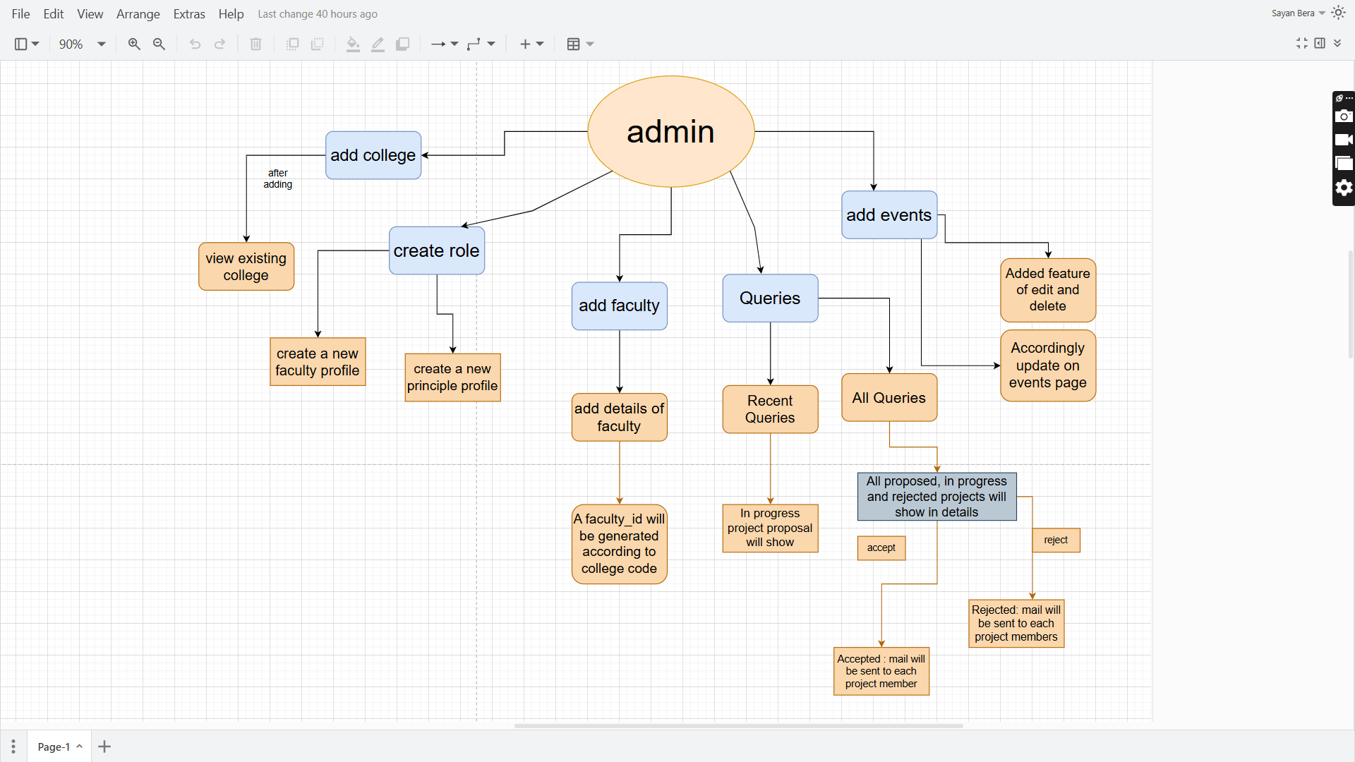

**ii.principle side:**

**iii.faculty side:**

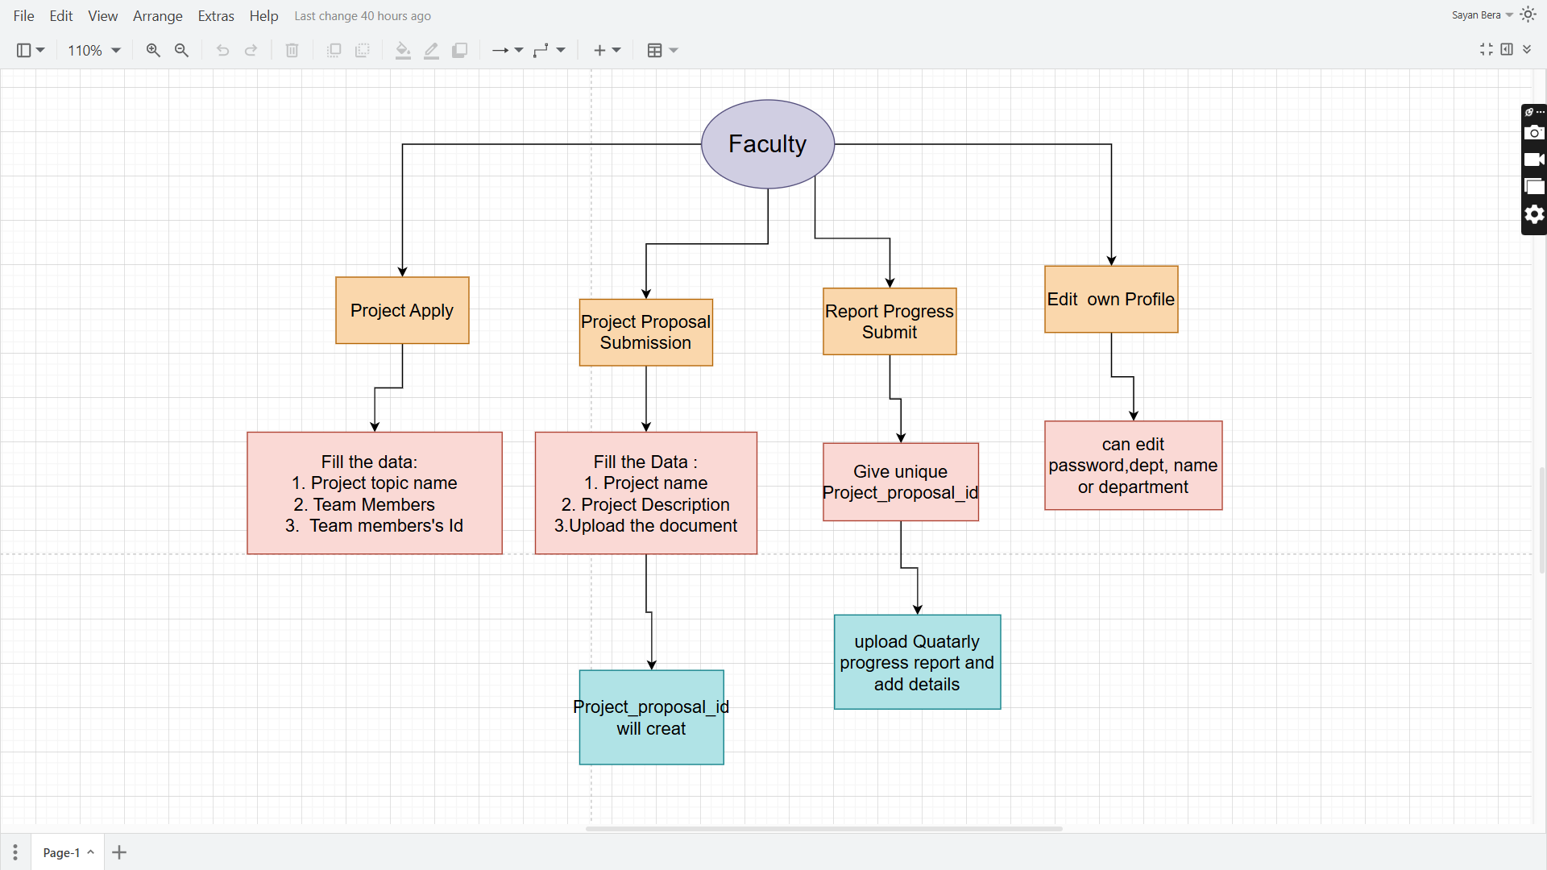

**5. Working Flow with Screenshots:**

**5.1.home page:**

home page contains

navbar including login button and logo and quick access link

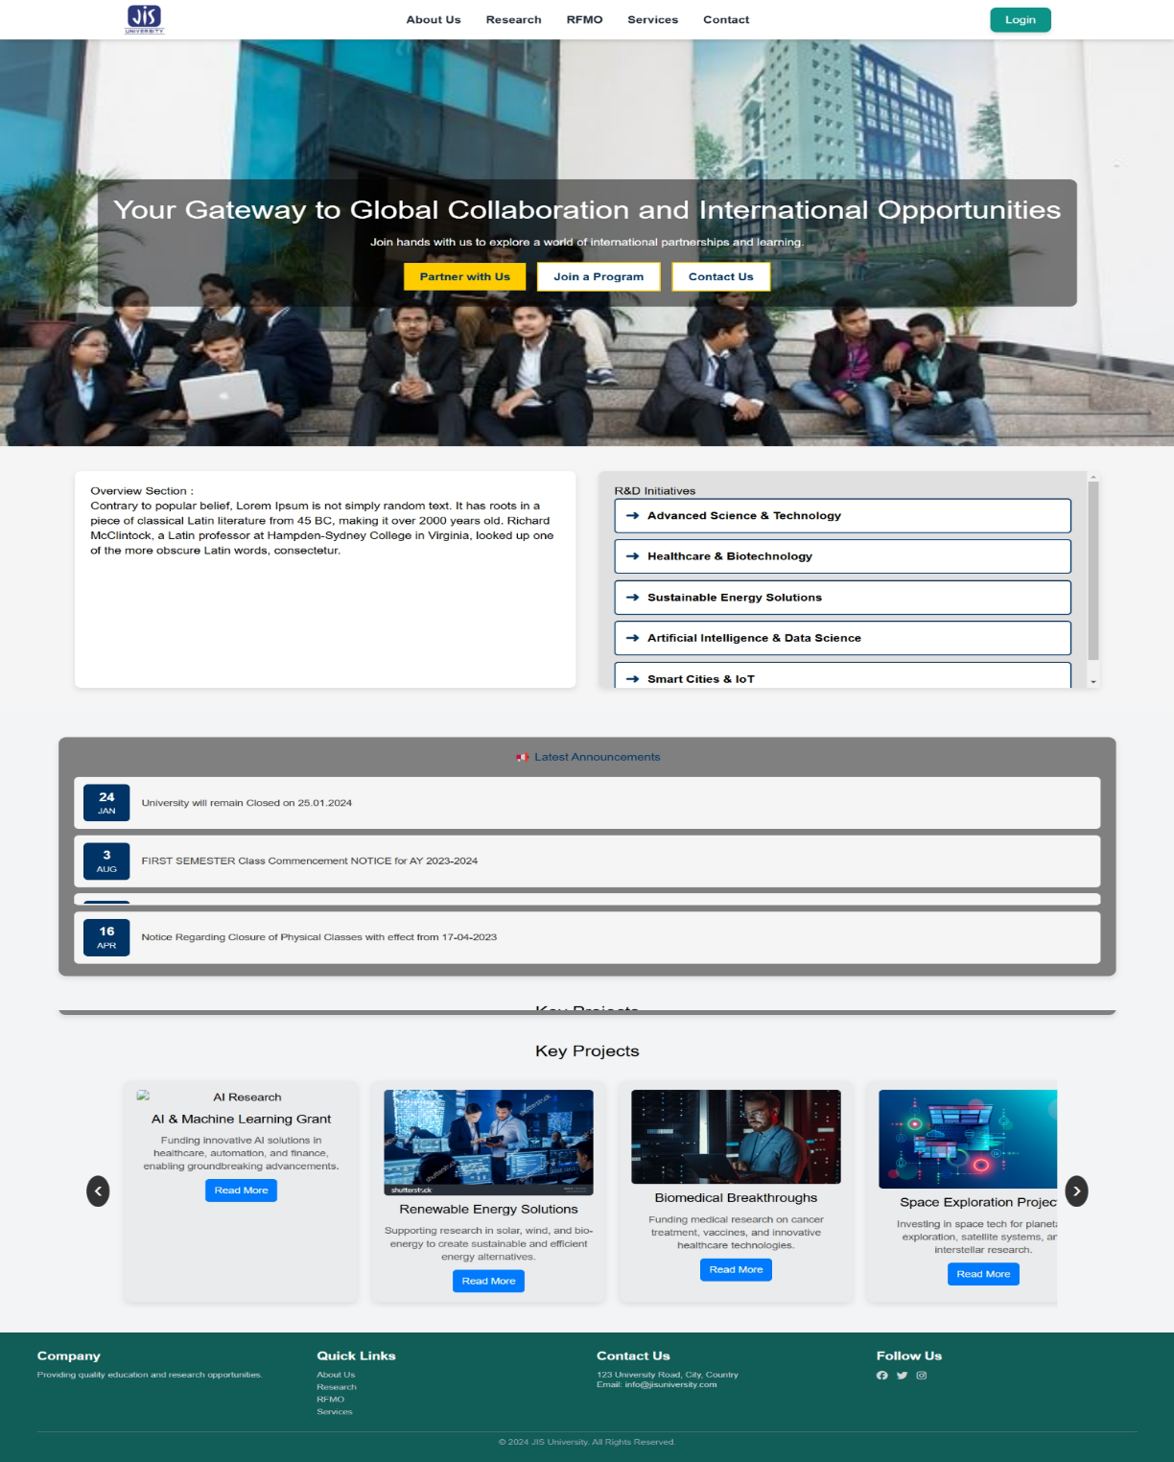

**5.1.login page:**

This page contains three types of login system

1. Admin login
2. Principle login
3. Faculty login

Along with OTP verification feature

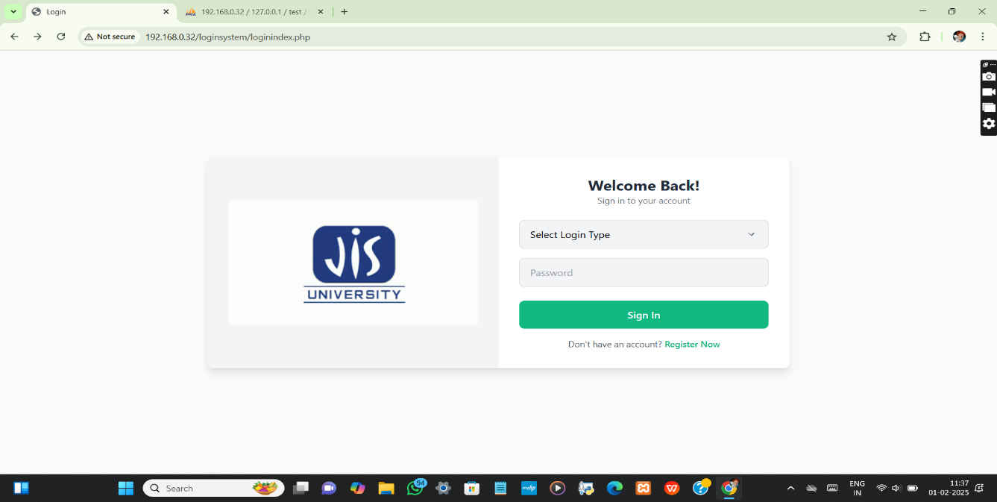

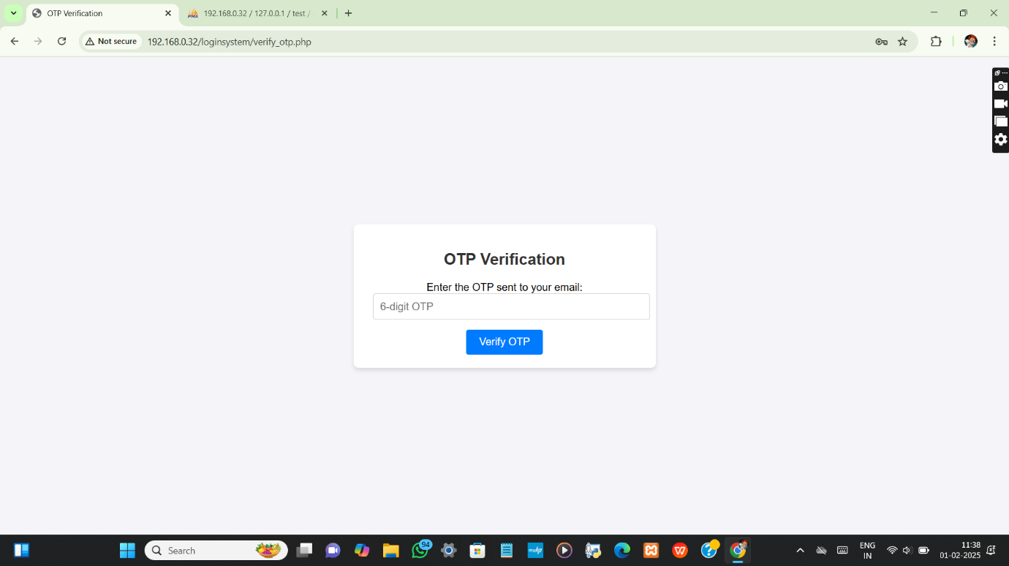

**5.1.1. Admin login page:**

After logging into as admin admin dashboard will open including

1. Add college
2. Create role
3. View existing college
4. Edit data
5. Add faculty
6. Recent queries
7. All queries
8. Add events
9. Inquiries
10. Project proposals
11. Progress reports

**1. Add college:**

Admin can manually add unique college code and college name in this section.

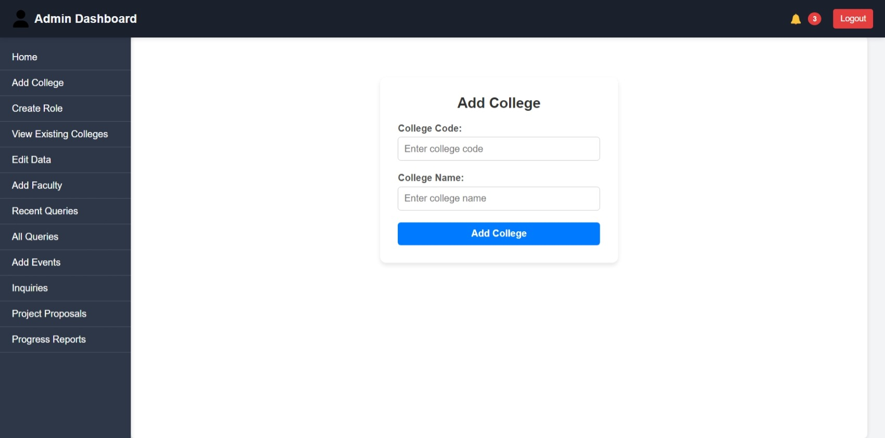

**II. Create Role :**

Admin can add new role – Faculty or Principle.

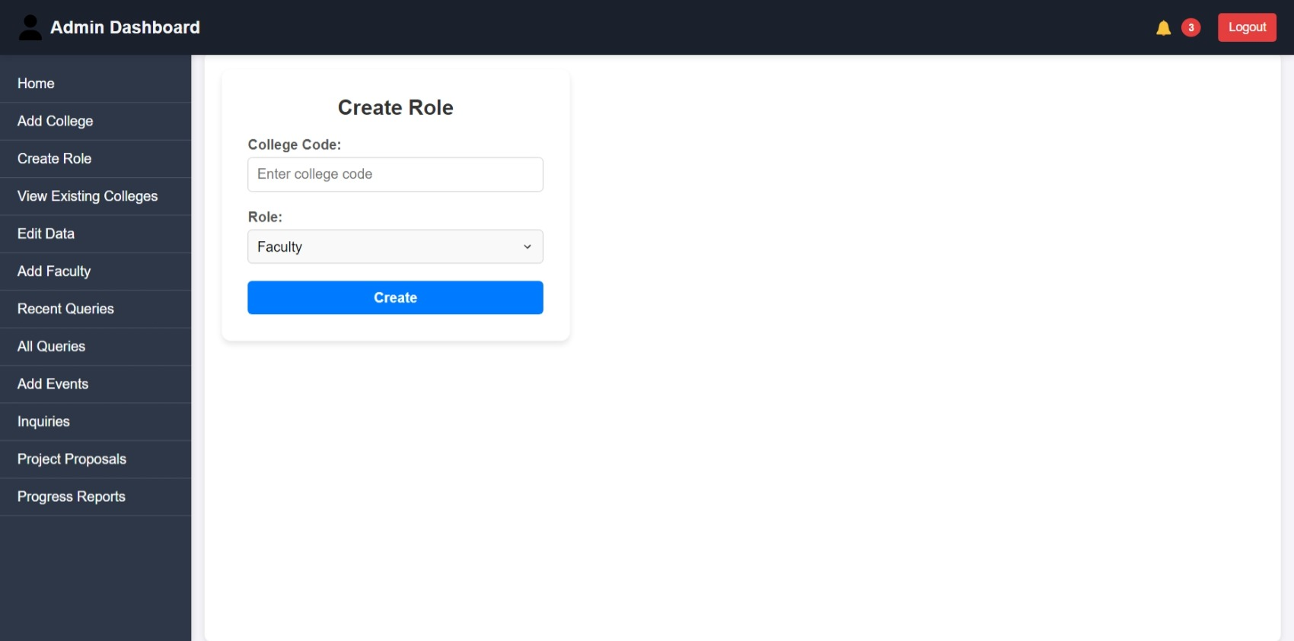

* Faculty or principal will be added according to the college table according to the corresponding college code.
* A unique id will be generated for each faculty.
* 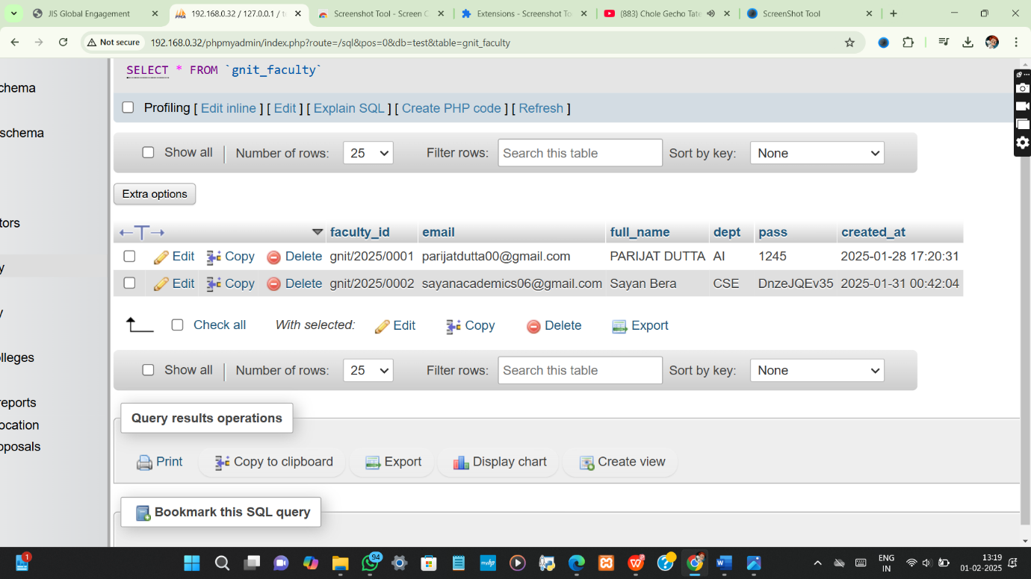

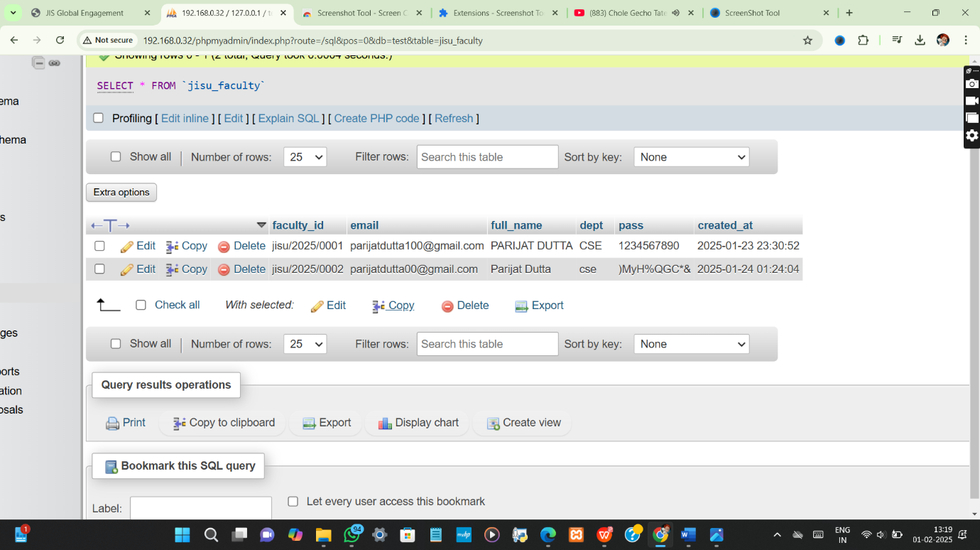

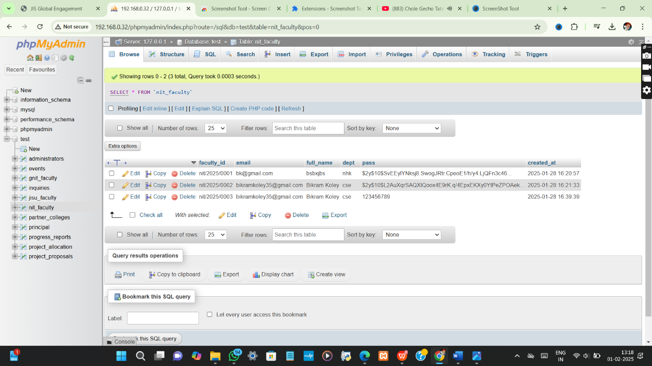

**III. View Existing College**

Added college by admin in “Add college Page” will be shown in “View existing college” with the corresponding college ID.

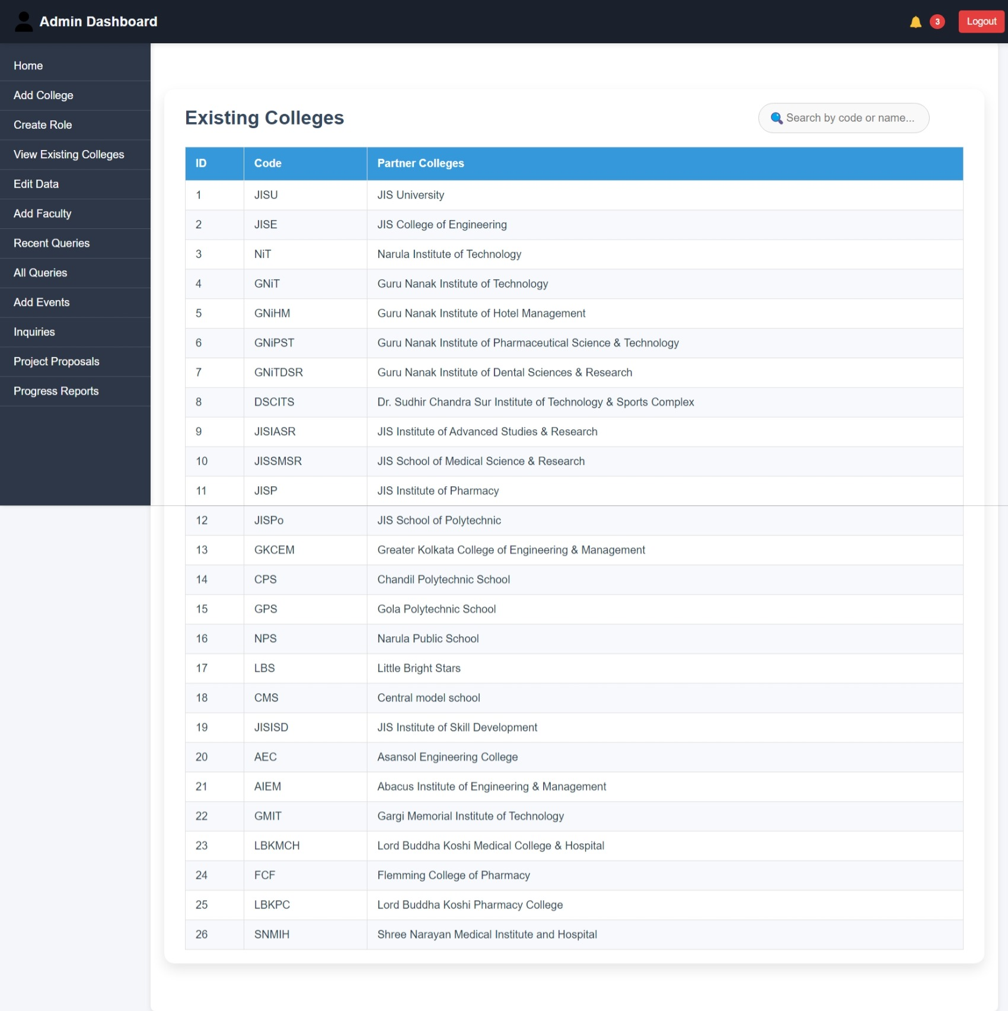

**IV. Edit data**

In this section already existing college data , faculty data & principal data can be edited.

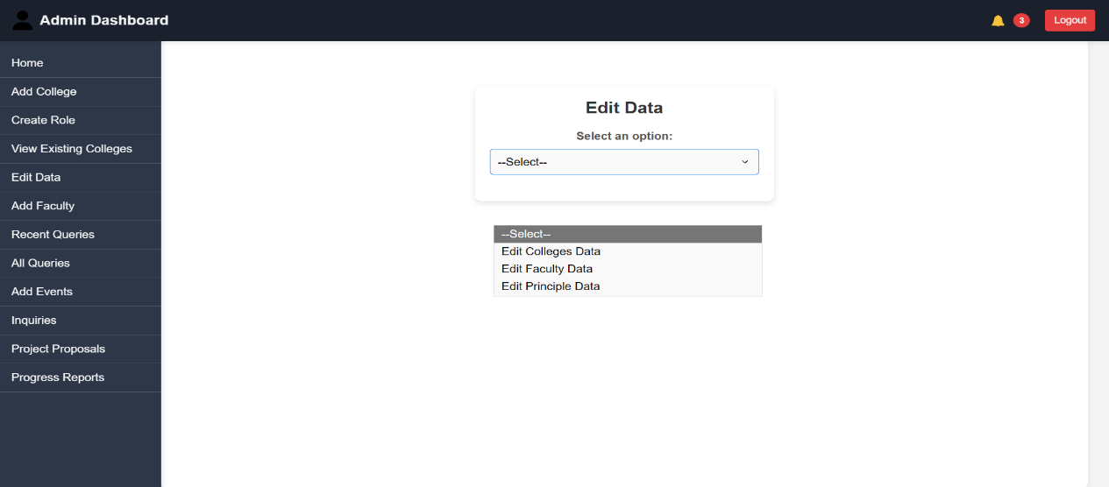

**V.Add Faculty:**

New Faculty details can be added.

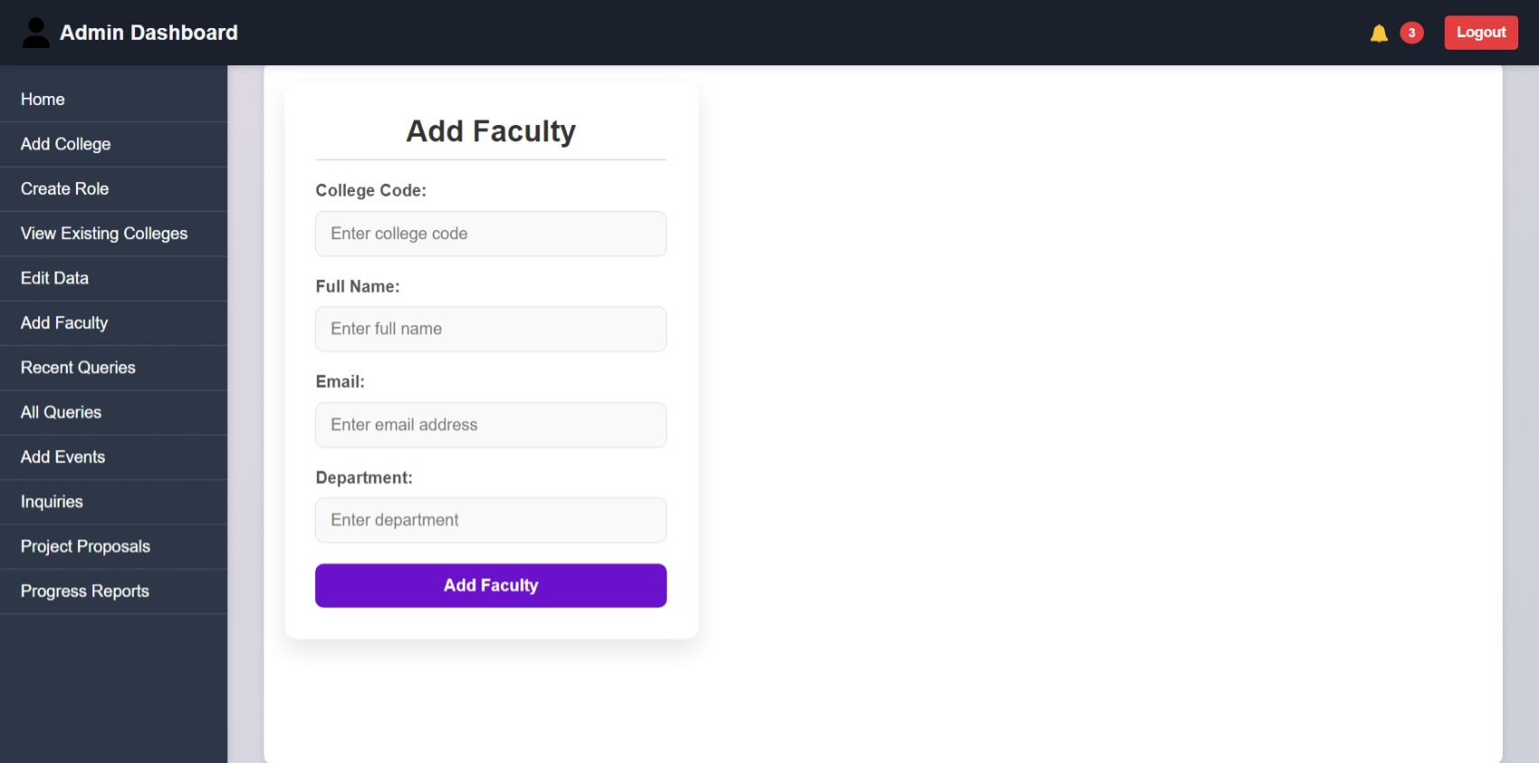

**VI.Recent Queries:**

In this section all proposed projects or ongoing or completed projects along with their current status and leader faculty id will shown up.

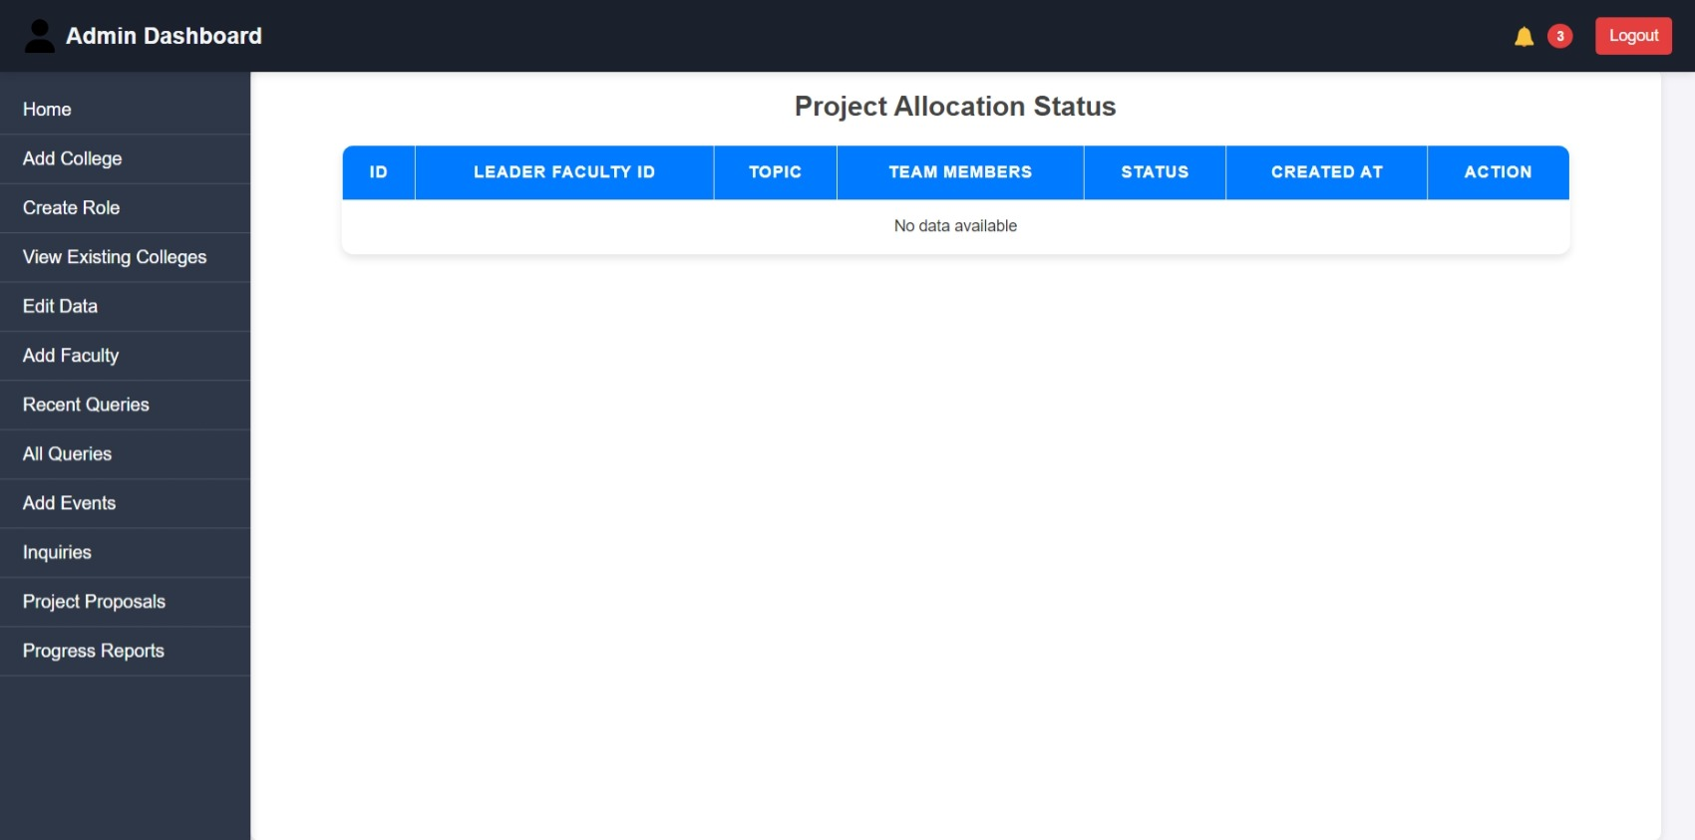

**VII. All Queries:**

Admin can give allocation permission (either ACCEPT or REJECT) to proposed projects.

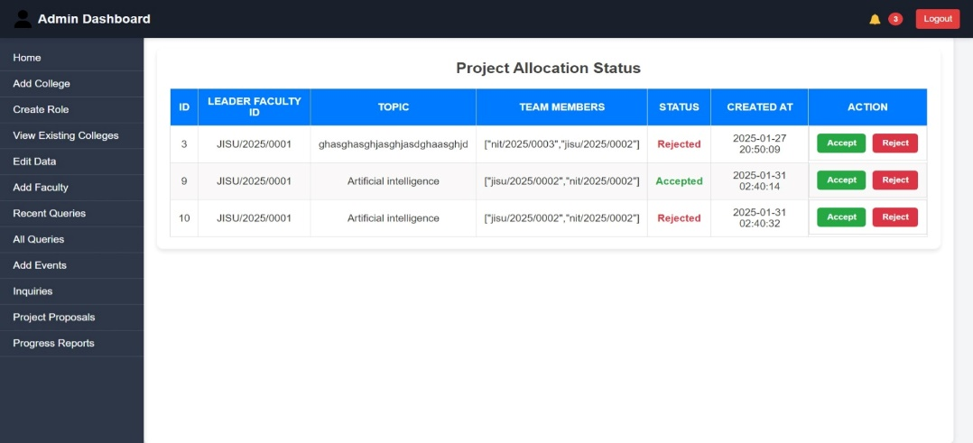

**VIII. Add Events:**

Can edit or add new events or notice in this section which will be shown In the main event page.

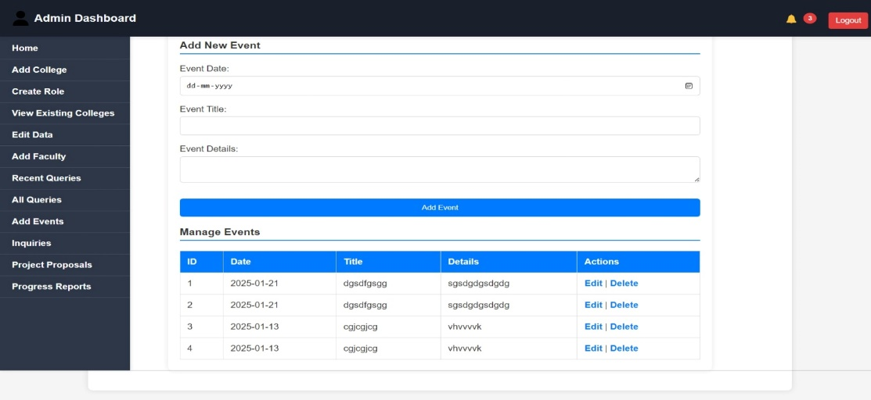

**IX. Inquiries :**

Whatever inquiries are received by inquiry form, the admin can reply to them from this section.

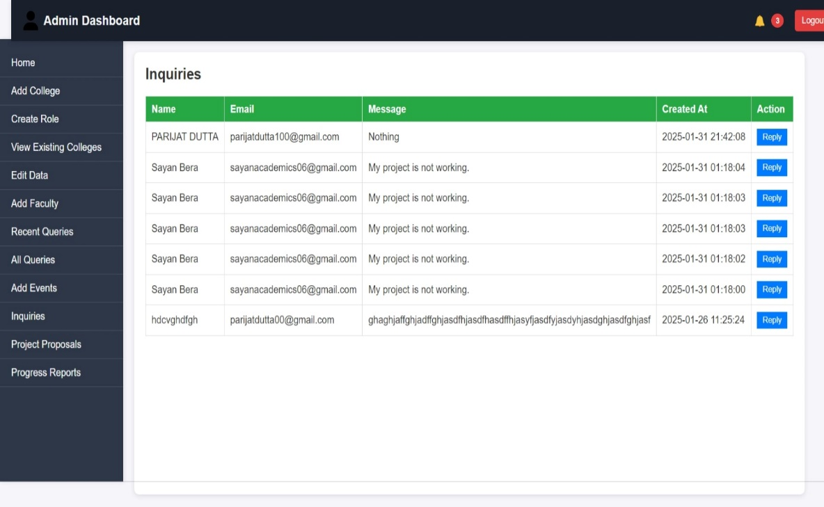

**X. Project Proposals:**

All proposed project details can be shown here along with their downloadable pdf file.

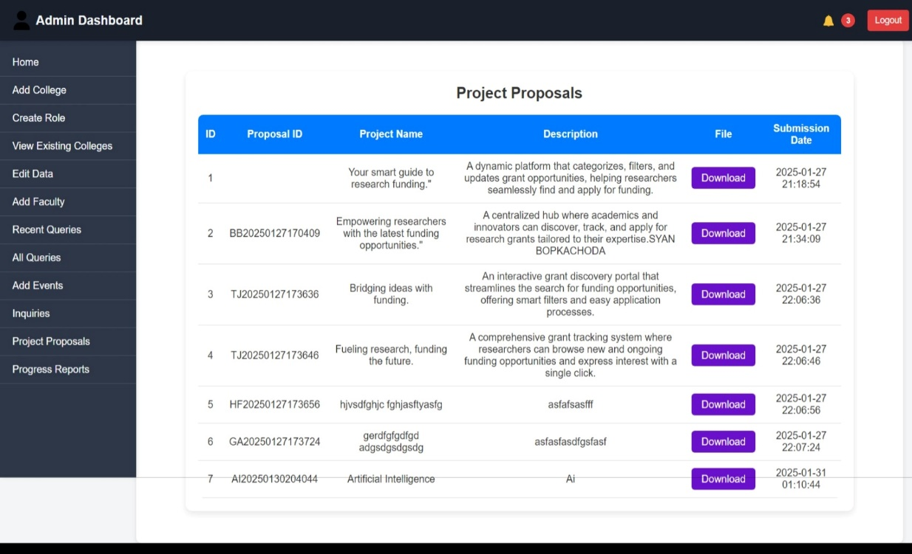

**XI.Progress Reports :**

Progress report details of each project will be shown here in this section.

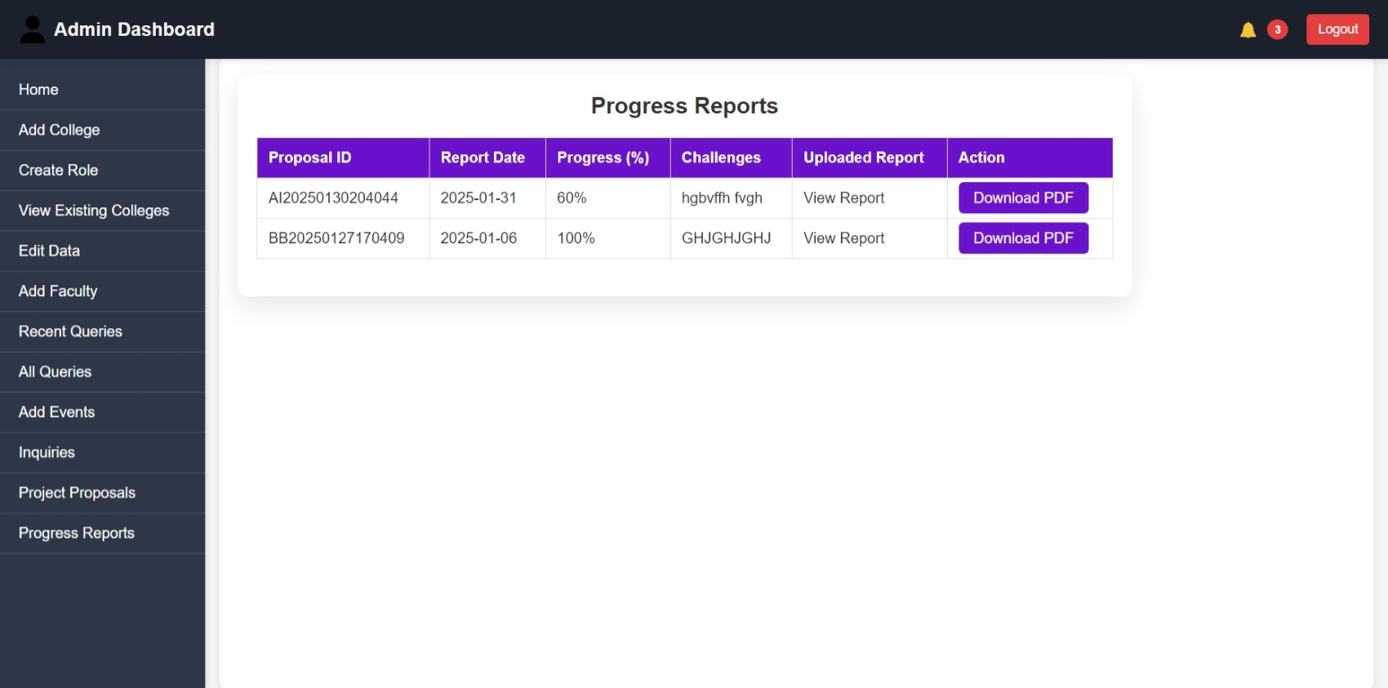

**4.1.2. Faculty login page:**

After logging in as Faculty, the FAculty dashboard will open including

1. Project Apply
2. Project Proposal submission
3. Progress Report
4. Edit My profile

**I.Project Apply :**

Faculty will apply for a project along with PROJECT NAME, TEAM MEMBERS’ NUMBER , NAME, and FACULTY_ID.

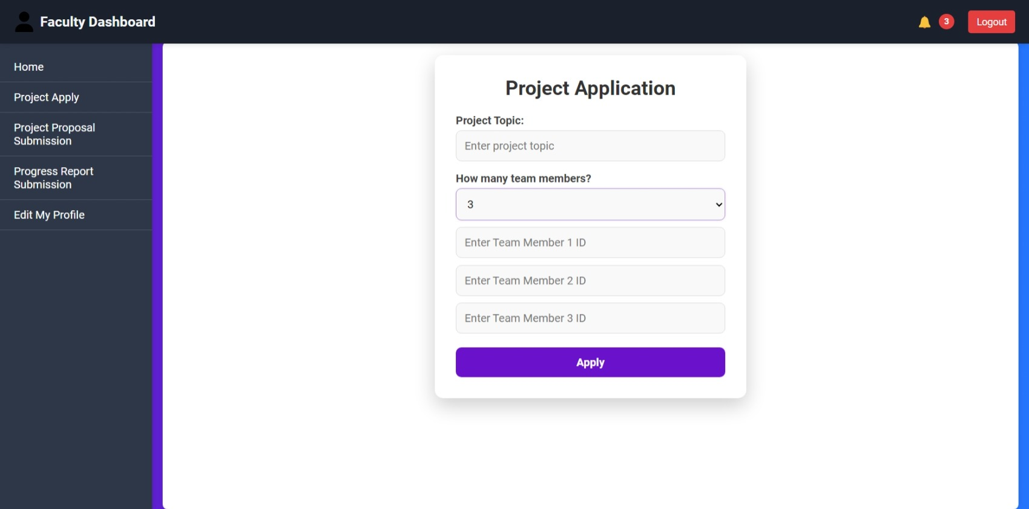

**II.Project proposal submission :**

Faculty can give details about their project name, and description along with report document.

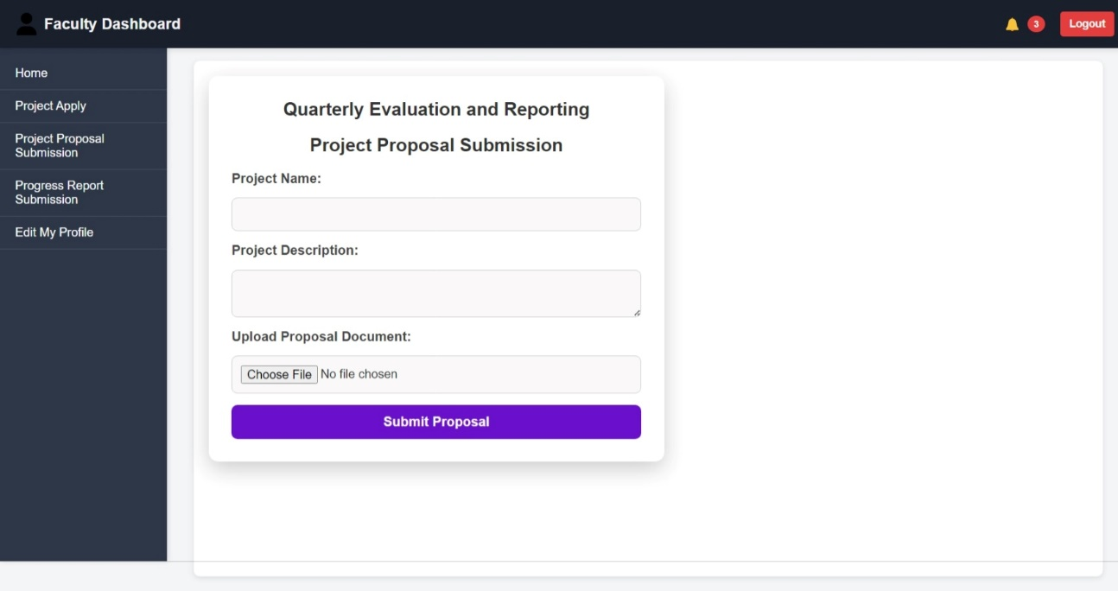

**III. Edit my Profile :**

Faculty can edit Their name, email id, department and also password for login .

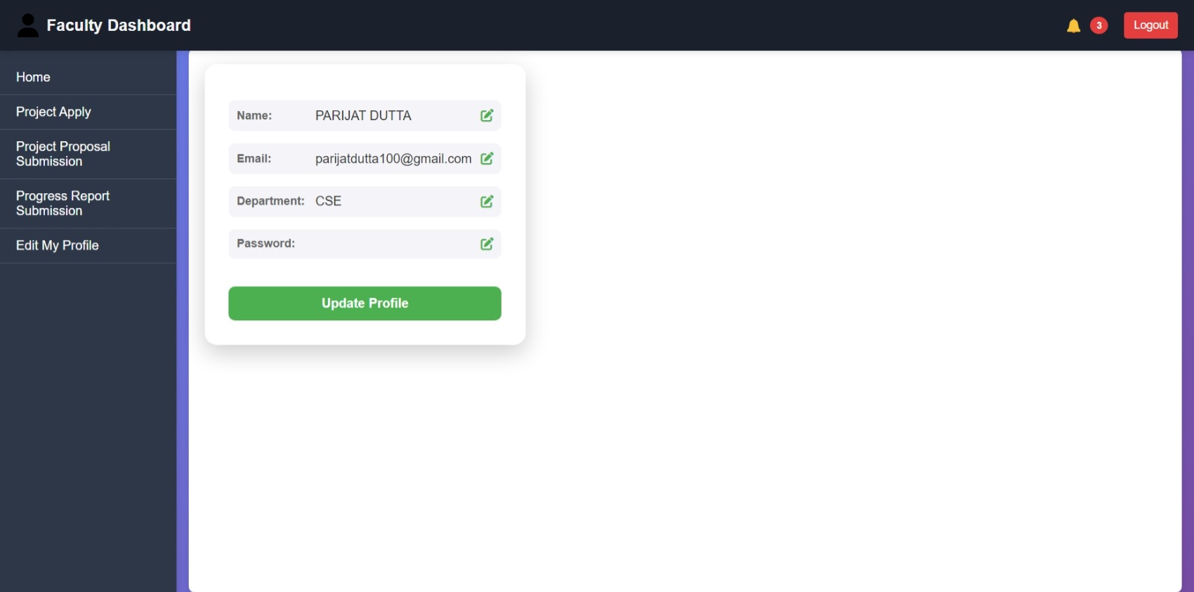

**5.2 Aboutus page:**

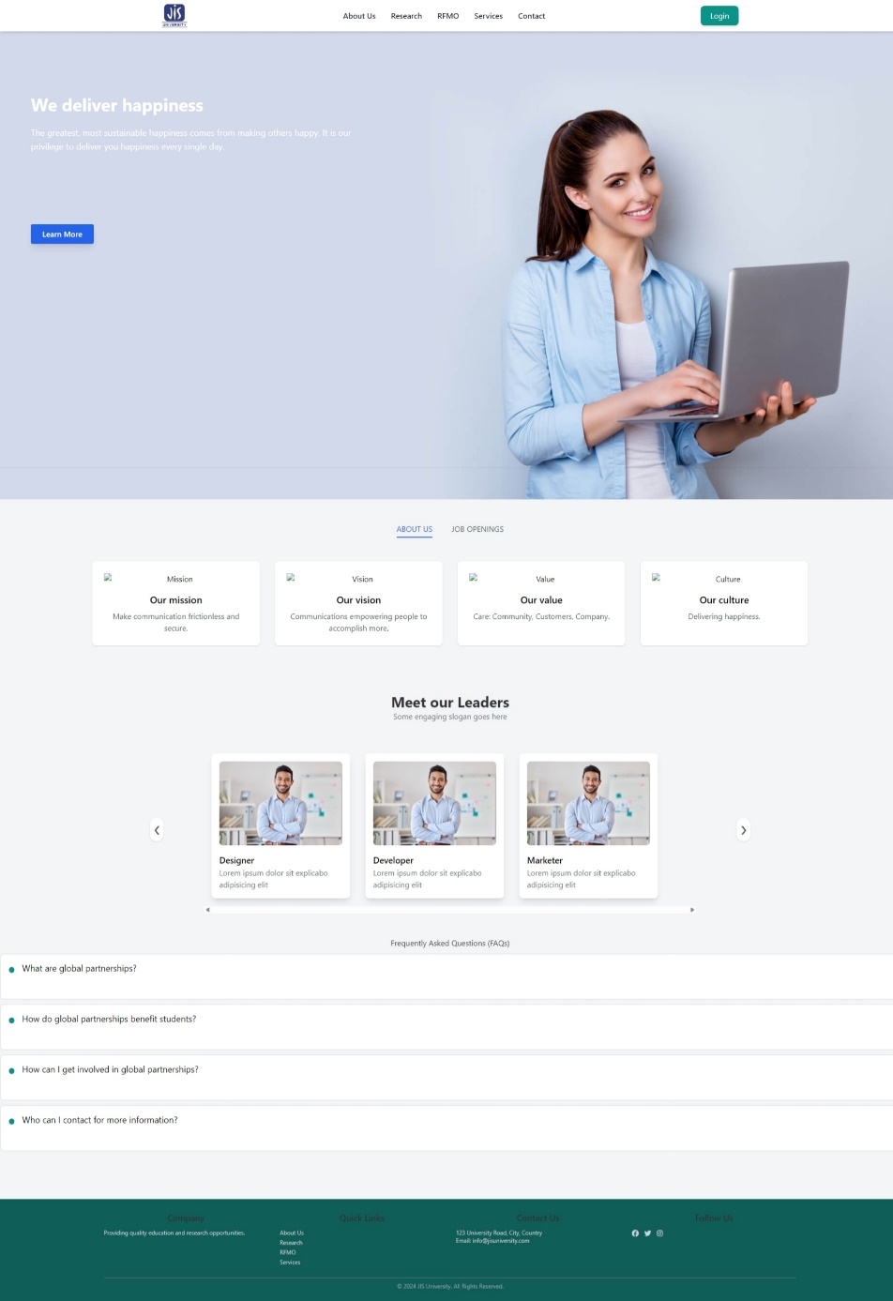

**5.3 Events page :**

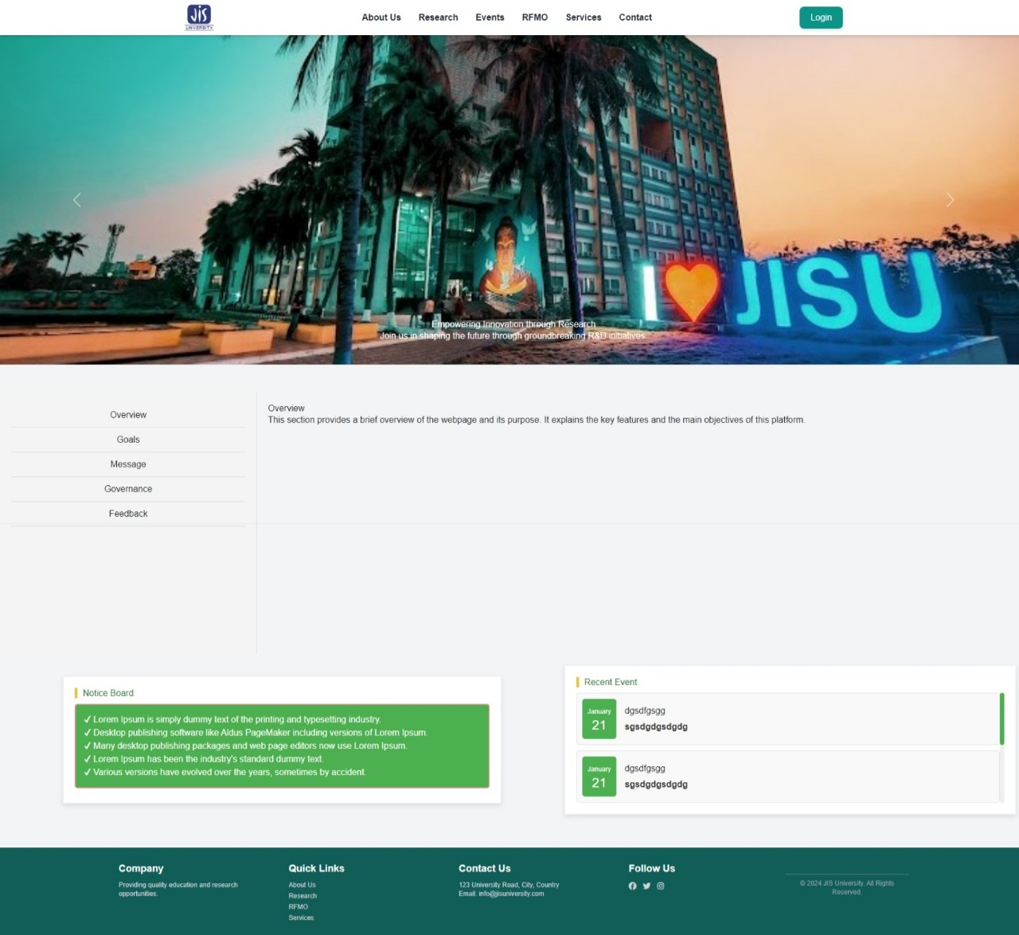

**5.4 Service page :**

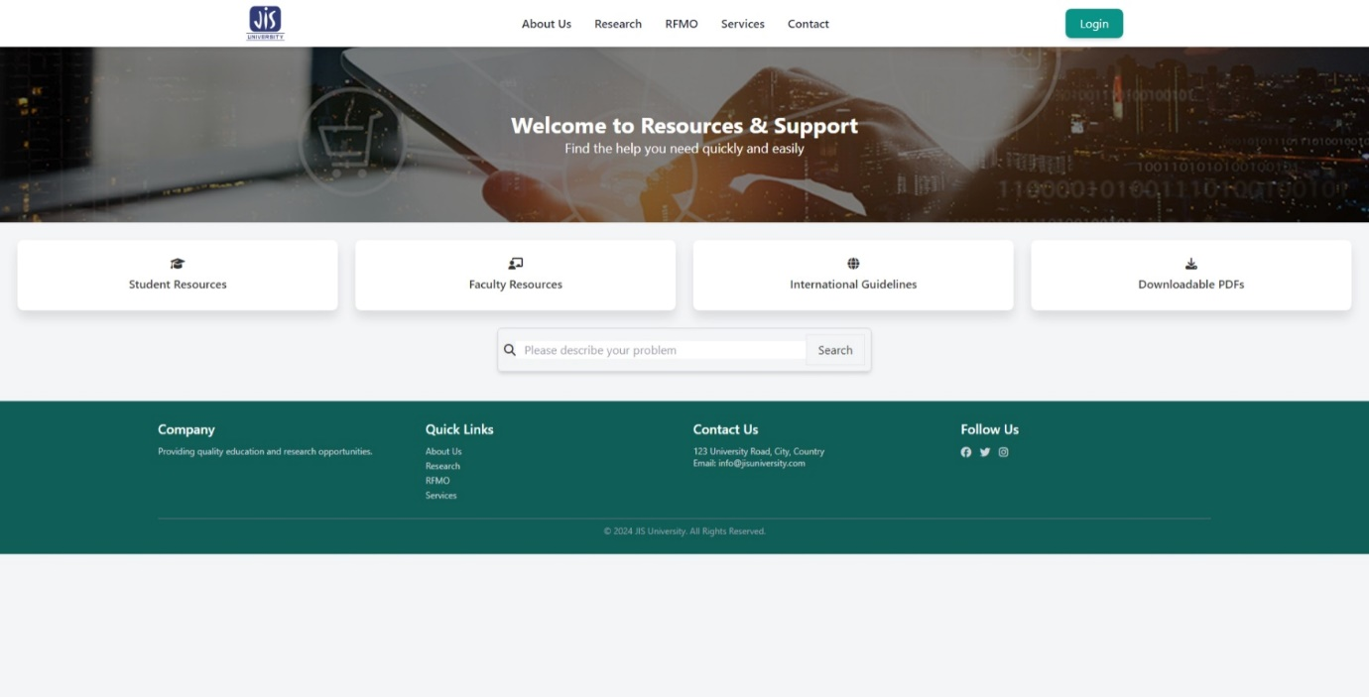

**5.5 RFMO page :**

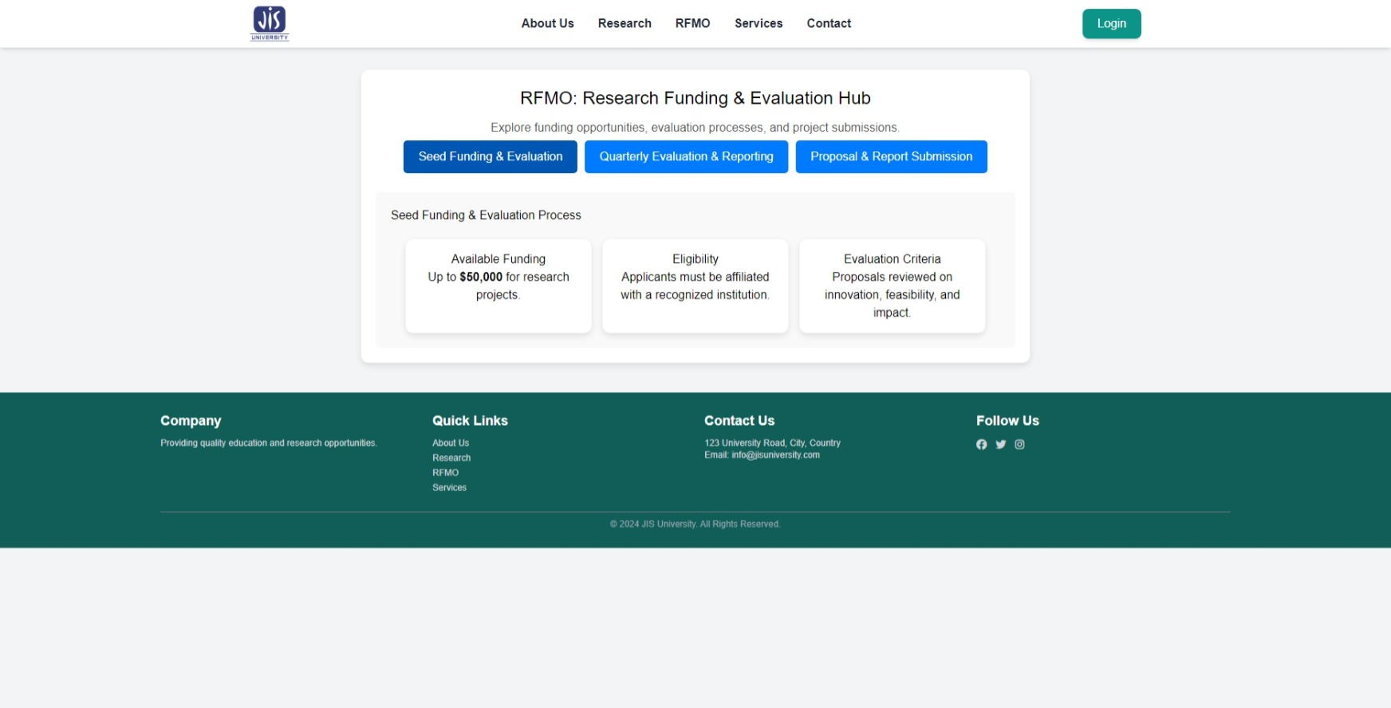

**6. Testing & Debugging**

Testing Methods Used:

1. Manual Testing
   * Functional Testing → Ensures that features like login, project submission, and grant tracking work as expected.
   * UI/UX Testing → Checks responsiveness, accessibility, and overall user experience.
   * Security Testing → Tests authentication, role-based access control, and data protection mechanisms.
   * Performance Testing → Measures load time, database queries, and API response times.
2. Automated Testing
   * Unit Testing → Uses tools like Jest (JavaScript) or PyTest (Python) to test individual components.
   * Integration Testing → Ensures APIs, database interactions, and frontend-backend communication work smoothly.
   * End-to-End (E2E) Testing → Uses tools like Selenium or Cypress to simulate real user interactions.